Indoor Interactive 32" 4K BizetBeeBoard® SBM
Freedom. Elegance. Performance.
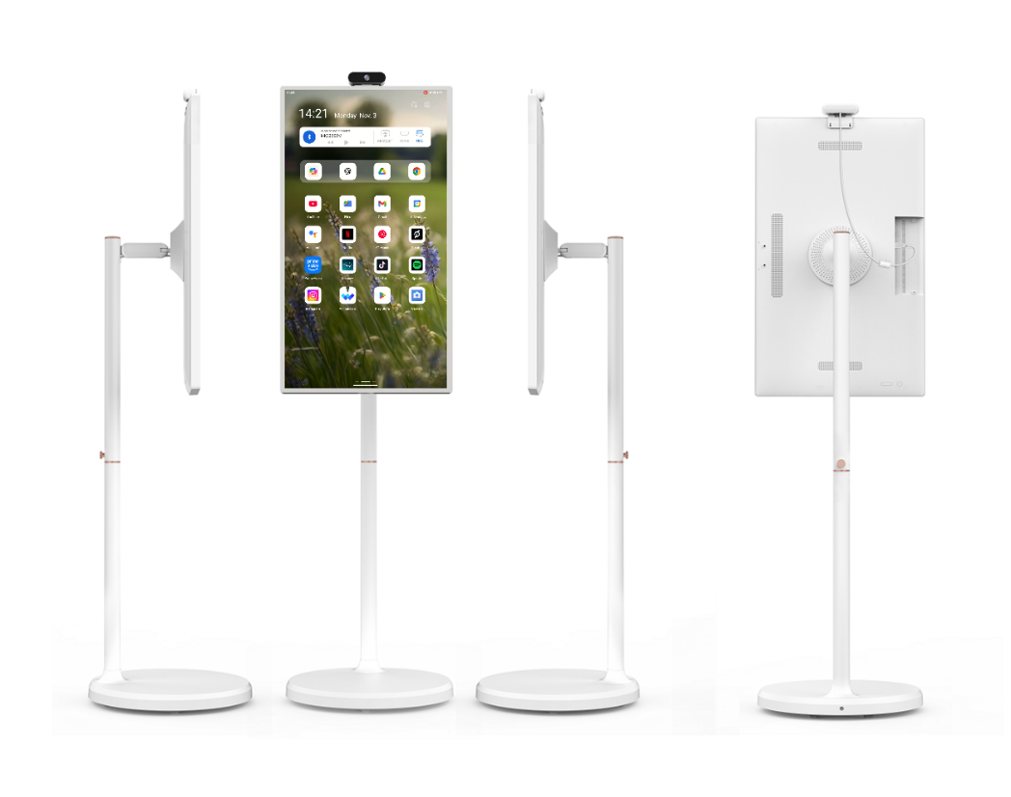

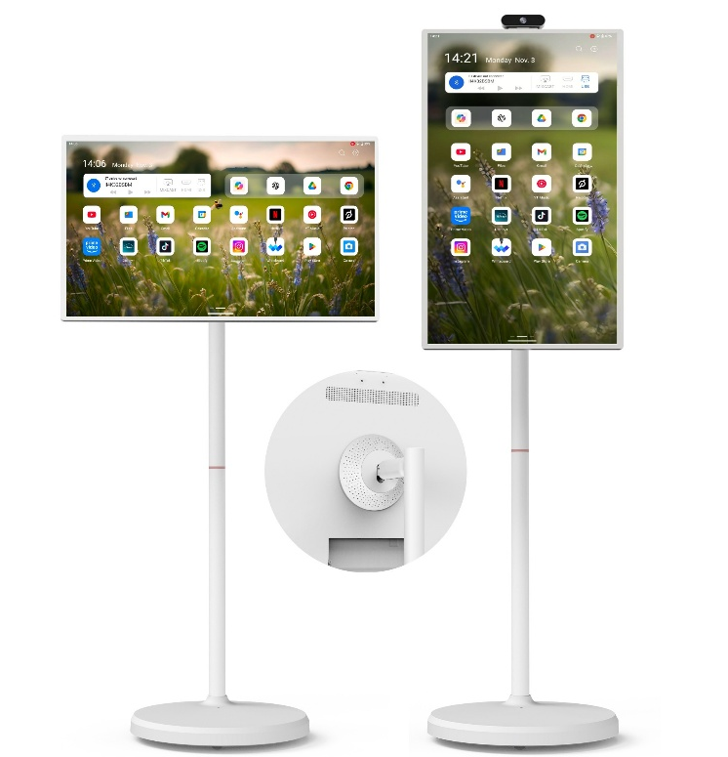
Experience the perfect blend of power, portability, and precision with the BizetBeeBoard® 32” Battery Powered Display — designed for modern businesses, interactive presentations, and immersive customer engagement.

Built with a stunning 4K Ultra HD touchscreen, it delivers life like clarity and vibrant detail, turning any space into a dynamic visual experience. The 10-point capacitive touch technology ensures smooth, responsive interaction for every user.

Effortless Adjustability
Its sleek ergonomic stand allows for height, tilt, swivel, and pivot adjustments, giving
you the flexibility to present your content in portrait or landscape with just a touch.
Perfectly balanced engineering ensures both stability and style in any setup. Every motion feels smooth and precise, supported by a solid, minimalist structure.

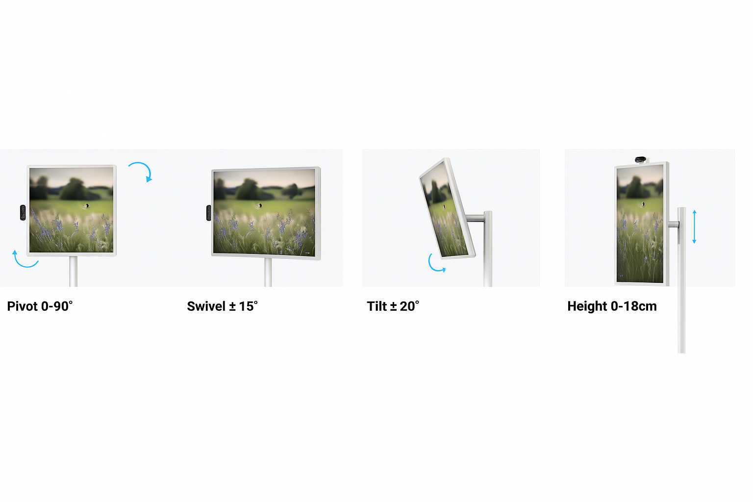
Made for Content Creation
Whether you’re editing TikToks, going live on Instagram, or filming a YouTube tutorial, this display gives you ultra-sharp 4K visuals and a 10-point touch screen that keeps up with your creativity. Rotate it vertically for the perfect portrait mode — ideal for Reels, Shorts, and TikTok videos.
All the Angles You Need
Switch between horizontal and vertical with a simple pivot.
Tilt, swivel, or raise it to get your best angle every time — no tools, no hassle.
Mount it to the wall for a clean streaming setup or use the sleek desktop stand for a pro look on your desk.
Go Wireless. Stay Creative.
Forget the cords — you can shoot, edit, or display anywhere.
Perfect for pop-ups, live sessions, or mobile shoots. Just charge it once and take your studio on the go.
With a high-capacity Li-ion 15000 battery pack providing up to 8 hours of continuous operation, the BizetBeeBoard® SBM lets you move freely — whether it’s a retail floor, your own home, a trade show, or an interactive classroom.
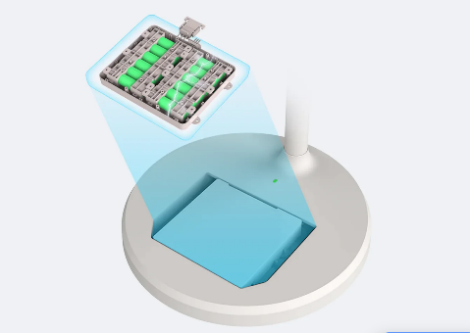

Smart Inside, Sleek Outside
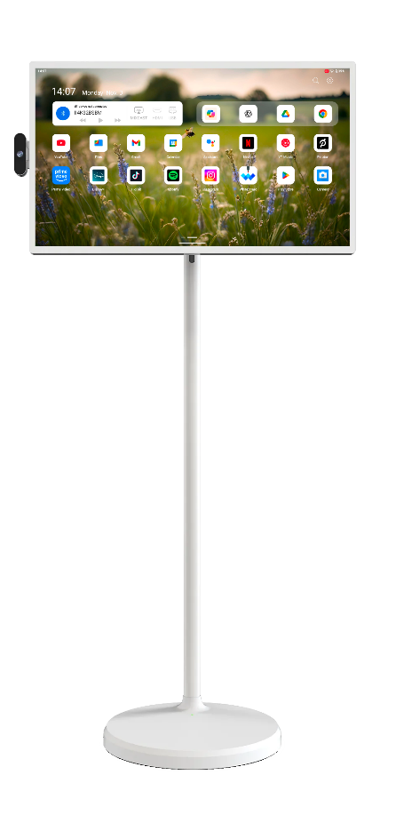
Powered by Android 14 and an 8-core processor multitasking is seamless — from streaming and signage to interactive apps. Integrated Wi-Fi 6 and Bluetooth 5.3 keep you connected, while the 4K camera and dual microphones make it ideal for high-quality video conferencing.

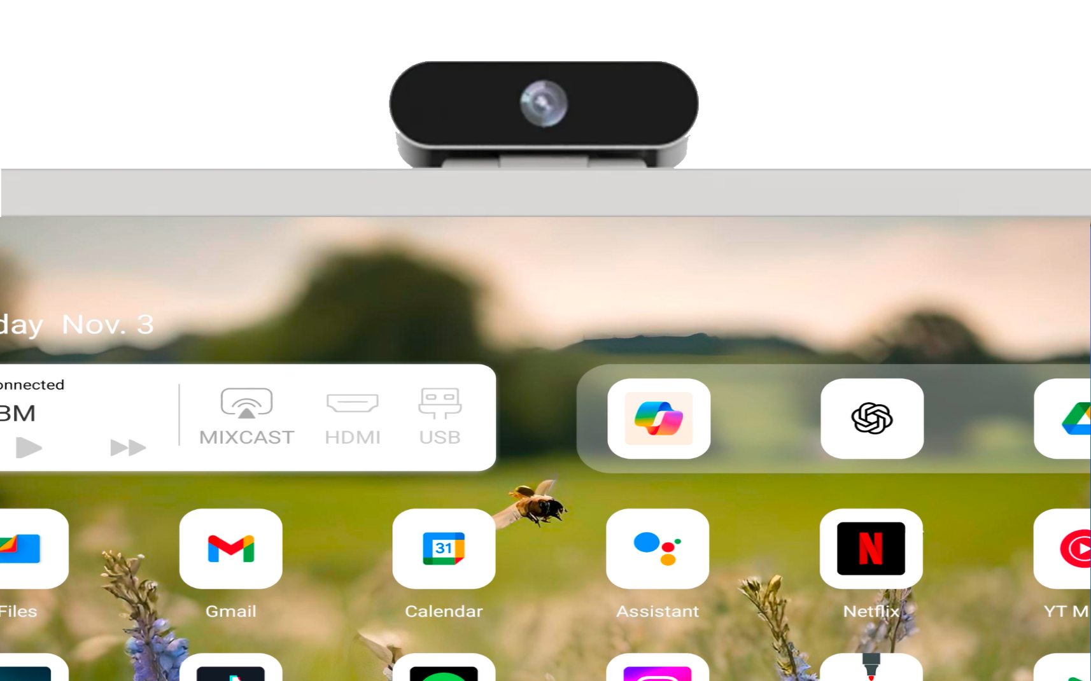

Tailored for Modern Business
Crafted with a minimalist design and available in elegant white or black, the
BizetBeeBoard® SBM enhances any professional environment. Use it as a digital kiosk,
interactive catalogue, menu board, or presentation display — and stand out with a
smarter, cleaner visual solution.
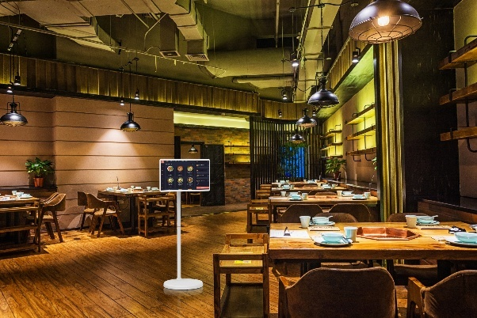
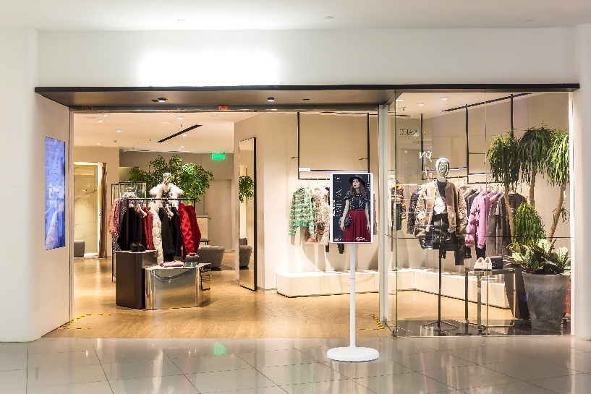

Your Display, Your Way.
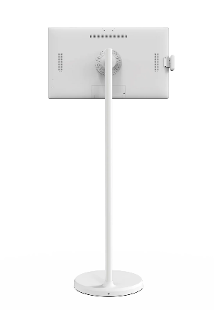
Desktop. Wall. Portable. The BizetBeeBoard® SBM gives you the power to choose — offering unmatched flexibility without compromising on performance or style.
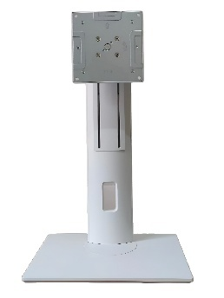
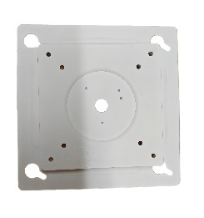

Designed for Every Environment.
Available in white powder-coated finish, this display complements any space — from boardrooms to boutiques always with unmatched refinement and clarity.
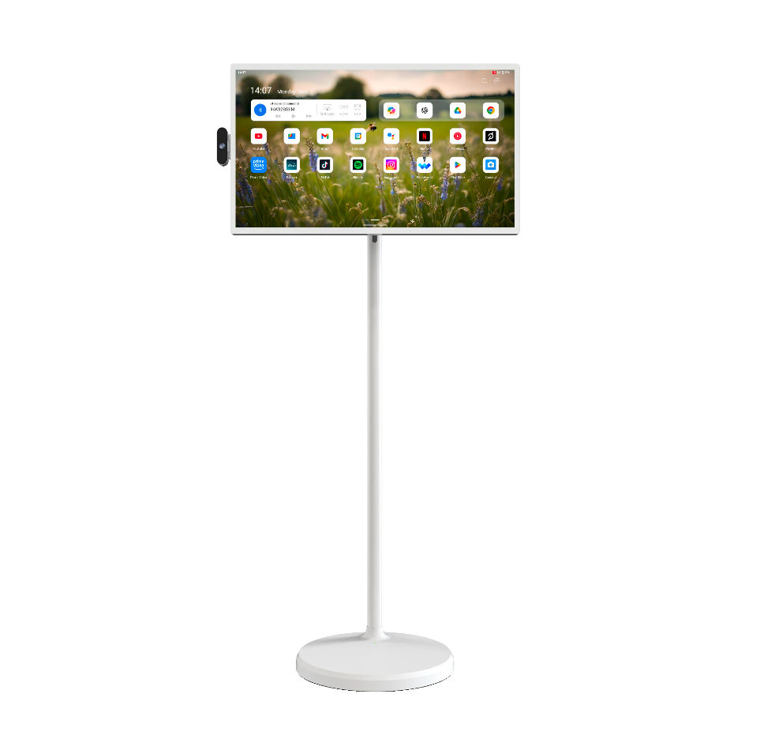

Create without limits. Present without boundaries. Wherever you go, the BizetBeeBoard® SBM goes with you.

